NAME -------------------------------------------- STREAM, -----------

MAKERERE COLLEGE SCHOOL
S3. MOT TERM II 2010
ADD-MATHEMATICS

Answer ALL questions:

1. Solve the equation:
4cot² θ + 39 = cosec θ.
for values of θ from 0º to 360º inclusive.

2. If sin A = 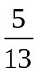 and cos B = where A is obtuse and B is acute,
find the values of:
(a) tan(A – B) (b) Cos (A + B).

3. Express in surd form and rationalize:

(a) 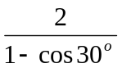 (b) 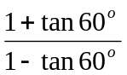.

4. The roots of the equation 2x² + 5x – 6 = 0
are α and β. Find the value of
(i) α² β + α β² (ii)) 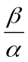 + 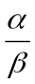 .

5. Differentiate with respect to x:
(x + 5)² (x – 1).

6. The function f(x) = x⁴ + ax³ + bx² - 5x + 3 has a remainder of (2x + 1)
When divided by x² + 3x + 2. Find the values of a and b.

7. Sketch the graph of cos (θ + 60º) for values of θ from - 180º to 180º stating the period, maximum and minimum of the function.

8. A particle moves in a straight line so that after ts, its distance from a fixed point
is given by s = 45t + 11t² - t³. Find :
- the velocity and acceleration after 3s.
- the time when the particle comes to rest.

************

